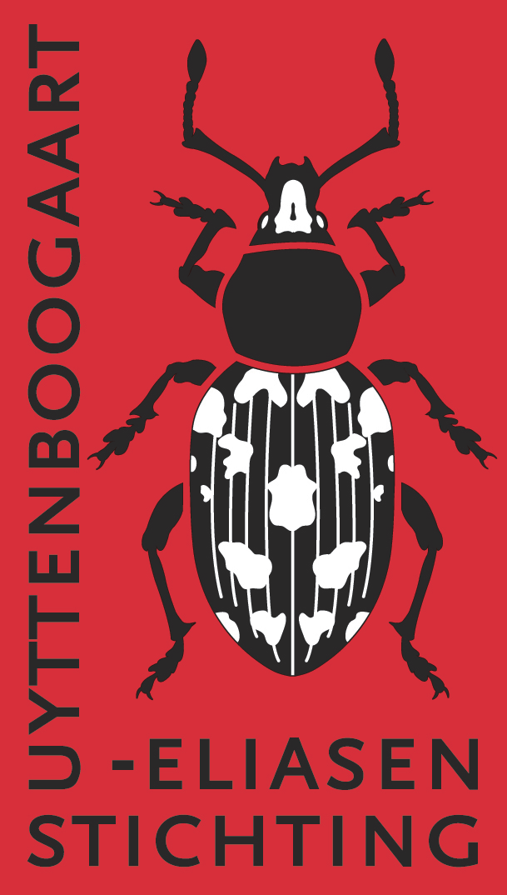 | Uyttenboogaart-Eliasen Stichting  Supporting Entomological Research  in the Netherlands  www.ue-stichting.nl

Application form (C) subsidy CONGRESS PARTICIPATION

This form is intended for applications on a congress participation only. In addition UES supports entomological research, study visit, expeditions, entomological publications and congress participations. Please use the specific forms available from www.ue-stichting.nl in those cases.
Please first read the General and Specific Guidelines for subsidy applications. Applications which do not comply with these guidelines and that do not use this application form will not be taken into considered.

A subsidy application (on a completed application form) should be sent (as MS Word file or –preferably– as PDF) by e-mail to the Secretariat of the UE-Foundation:

De heer Jaap van der Bijl
Nassauplein 9, 2011 PG Haarlem
Tel +31 6 1901 2190
E-mail uestichting@gmail.com

Applications may be submitted any time of year, but preferably shortly before one of the closing dates of the May and December meetings of the board of the UES: April 15 and November 15. Applications submitted after the closing date will, if still applicable, be assessed at the next meeting.

Personal data

Family name:

First name:

Date of birth:

Professional position (function), field of study, retired:
Address:

ZIP code and city:

Phone:

E-mail:

Bank account (IBAN):

Congress or symposium participation

C.1. CONGRESS
Title of the project (study visit) for which a grant is requested.

C.2. LOCATION WHERE CONGRESS WILL BE HELD
Provide city and country where congress will be held.

C.3. TITLE
Title of the presentation.

C.4. DOES THE PRESENTATION CONCERN A LECTURE OR A POSTER?
The presentation concerns an oral lecture or a poster.

C.5. AUTHOR(S)
Who are the author(s) and who is the presenter of the presentation?

C.6. SHORT DESCRIPTION
Provide an overview of the presentation. (max 150 words)

C.7. START DATE OF congress:

C.8. END DATE OF congress:

C.9. SCIENTIFIC SIGNIFICANCE FOR THE NETHERLANDS’ ENTOMOLOGY
How will the congress participation promote entomology in the Netherlands (max 50 words).

C.10. EARLIER PUBLICATIONS CONCERNING THIS SUBJECT BY APPLICANT
Provide titles of earlier publications concerning the subject of the application (separate sheet may be used for this).

When applying in the context of a PhD study:

E.11. START AND END DATE OF PhD- RESEARCH CONTRACT
Starting date of research contract. | End date of research contract.

E.12. TITLE OF YOUR PHD PROJECT
Provide the title of your PhD research project.

E.13. NAME OF (CO-)PROMOTOR (a letter of support should be attached)
Name of (co-)promotor. (A letter of support has to be attached).

E.14. NAME OF SUPERVISOR
Name of daily supervisor of your PhD research project.
Budget (in EUR)

Provide a detailed breakdown of expenditure following the table below. Any income of the entire project (when applicable) should be listed.
The relevance of the listed budget lines below depends on the nature of the project for which a subsidy is requested and the breakdown to be given is in accordance with this. If not applicable, indicate ‘NA’ in the column Details.

COSTS

Item | Details | Amount
Travel expenses international | (means of transport)
Travel expenses local | (means of transport)
Housing | (number of days and type of accommodation)
Costs of living | (number of days)
Congress | (registration fee)
Other costs
Total costs of the project

OTHER CONTRIBUTIONS AND REVENUES
Include relevant documentation as attachment.

Contribution from | Details | Amount
Applicant
Employer or educational institution | (name and address)
Other funding | (name and address)
...
Total contributions etc.

AMOUNT REQUESTED AS UES SUBSIDY

SUBMISSION DATE

