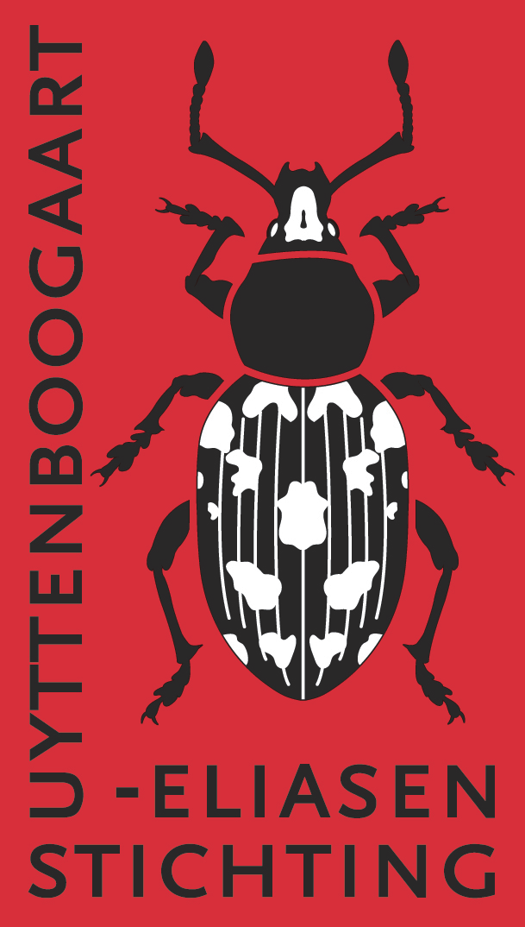 | Uyttenboogaart-Eliasen Stichting  Supporting Entomological Research  in the Netherlands  www.ue-stichting.nl

Application form (E) subsidy EXPEDITION

This form is intended for applications on an expedition only. In addition UES supports entomological research, study visits, entomological publications and congress participations. Please use the specific forms available from www.ue-stichting.nl in those cases.
Please first read the General and Specific Guidelines for subsidy applications. Applications which do not comply with these guidelines and that do not use this application form will not be taken into considered.

A subsidy application (on a completed application form) should be sent (as MS Word file or –preferably– as PDF) by e-mail to the Secretariat of the UE-Foundation:

De heer Jaap van der Bijl
Nassauplein 9, 2011 PG Haarlem
Tel +31 6 1901 2190
E-mail uestichting@gmail.com

Applications may be submitted any time of year, but preferably shortly before one of the closing dates of the May and December meetings of the board of the UES: April 15 and November 15. Applications submitted after the closing date will, if still applicable, be assessed at the next meeting.

Personal data

Family name:

First name:

Date of birth:

Professional position (function), field of study, retired:
Address:

ZIP code and city:

Phone:

E-mail:

Bank account (IBAN):

Expedition

E.1. TITLE
Title of the project (expedition) for which a grant is requested.

E.2. SHORT Description
A brief description (expedition) of the project (max 150 words).

E.3. START DATE OF THE EXPEDITION:

E.4. END DATE OF THE EXPEDITION:

E.5. CONTEXT OF THE EXPEDITION

Provide the scientific background of the project (expedition) (max 150 words).

E.6. OBJECTIVE, METHOD AND RESULT
Give a clear description of the objective and the way in which the results will be obtained. What results are expected? (max 150 words)

E.7. SCIENTIFIC SIGNIFICANCE FOR THE NETHERLANDS’ ENTOMOLOGY
How will the expedition contribute to development of entomology in the Netherlands (max 50 words).

E.8. CONTACT PERSONS
Who are the professional contact persons with regard to the project?

Collected entomological material

E.9. AT WHAT LOCATION WILL THE COLLECTED SPECIMENS BE STUDIED?

E.10. PUBLIC COLLECTION IN THE NETHERLANDS WHERE THE SPECIMENS EVENTUALLY WILL BE DEPOSITED

E.11. CONTACT PERSON WITH WHOM THE EVENTUAL DEPOSITION OF SPECIMENS AT THE MUSEUM IS ARRANGED AND THE DETAILS OF THIS ARRANGEMENT

E.12. WHEN WILL THESE SPECIMENS BE DEPOSITED THERE?

Budget (in EUR)

Provide a detailed breakdown of expenditure following the table below. Any income of the entire project (when applicable) should be listed.
The relevance of the listed budget lines below depends on the nature of the project for which a subsidy is requested and the breakdown to be given is in accordance with this. If not applicable, indicate ‘NA’ in the column Details.

COSTS

Contribution from | Details | Amount
Travel expenses international | (means of transport)
Travel expenses local | (means of transport)
Housing | (number of days and type of accommodation)
Costs of living | (number of days)
Materials
Other costs
Total contributions etc.

OTHER CONTRIBUTIONS AND REVENUES
Include relevant documentation as attachment.

Contribution from | Details | Amount
Applicant
Employer or educational institution | (name and address)
Other funding | (name and address)
...
Total contributions etc.

AMOUNT REQUESTED AS UES SUBSIDY

SUBMISSION DATE

